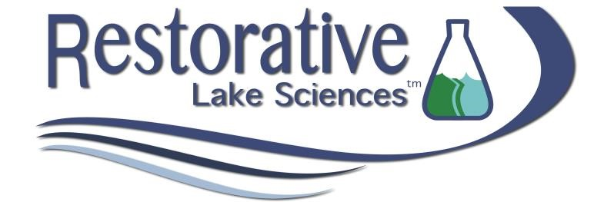
Barron Lake 2022 Aquatic Vegetation, Water Quality, and 2023 Management Recommendations Report

November
, 202
1

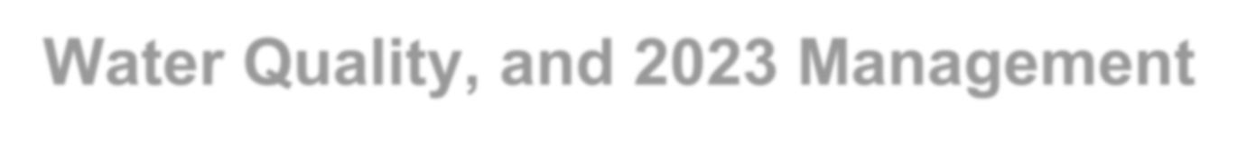
Barron Lake 2022 Aquatic Vegetation, Water Quality, and 2023 Management
Recommendations Report
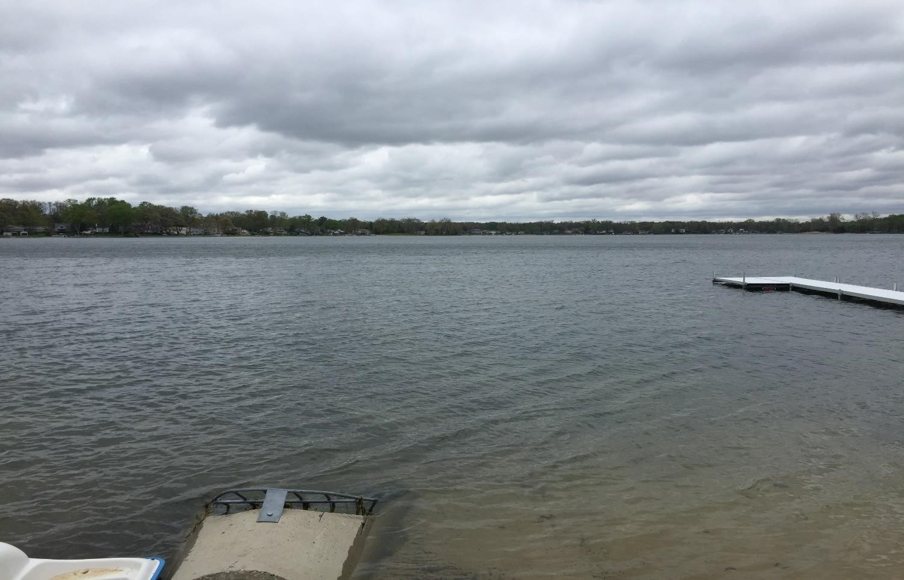

© Restorative Lake Sciences
18406 West Spring Lake Road Spring Lake, Michigan 49456
Website: http://www.restorativelakesciences.com

Table of Contents
Section 1: Barron Lake Summary (2022) ................................. 4

Section 2: Barron Lake Water Quality Data (2017-2022) .......... 5

Section 3: Barron Lake Aquatic Vegetation Data (2022) ........ 13

Section 4: Management Recommendations for 2023 ............. 19

Section 1
Barron Lake 2022 Aquatic

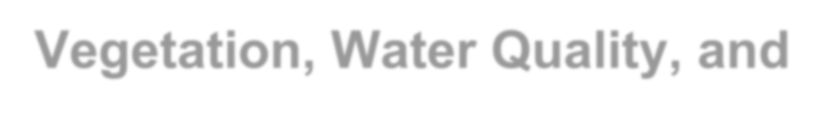
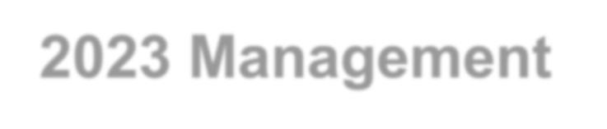
Vegetation, Water Quality, and
2023 Management
Recommendations

The following information is a summary of key lake findings collected during 2022.
T
total phosphorus and total nitrogen concentrations, great water he overall condition of Barron Lake in 2022 was good with moderate
clarity, moderate conductivity and favorable pH and total alkalinity.
The lake experienced lower water levels in 2021-2022 due to less rainfall which contributed less nutrients to the lake and allowed for better water clarity with less runoff.
The 2022 season revealed less growth of EWM and CLP which was favorable with treatment occurring on August 23, 2022. Since diquat was used in 2022, RLS recommends use of the new systemic herbicide, ProcellaCOR® with diquat in Barron Lake for 2023 to further improve treatment efficacy. RLS also recommends that individual property owners not have their shoreline areas treated unless the aquatic plants are at a very dense nuisance level. This is to allow for aquatic plants in the lake to compete with blue-green algae which are on the rise in numerous inland lakes. Once this algae becomes prevalent, most aquatic plants cannot grow and the algae can secrete toxins that significantly impair recreation on the lake.
Barron Lake has a favorable biodiversity of native aquatic plants, especially of pondweeds such as Large-leaf and Illinois Pondweed that are excellent fish cover and forage habitat.

Section 2

Barron Lake Water Quality Data (2022)

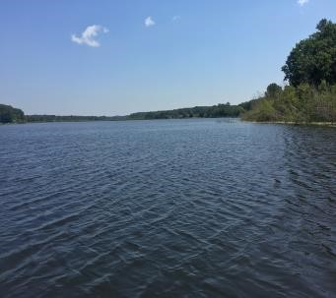
Water Quality Parameters Measured
There are hundreds of water quality parameters one can measure on an inland lake, but several are the most critical indicators of lake health. These parameters include water temperature (measured in °F), dissolved oxygen (measured in mg/L), pH (measured in standard units-SU), conductivity (measured in micro-Siemens per centimeter-µS/cm), total alkalinity or hardness (measured in mg of calcium carbonate per liter-mg CaCO₃/L), total dissolved solids (mg/L), secchi transparency (feet), total phosphorus and total nitrogen (both in mg/L), chlorophyll-a (in µg/L), and algal community composition. Water quality is measured in the deep basin of Barron Lake each year. Table 1 below demonstrates how lakes are classified based on key parameters. Barron Lake would be considered eutrophic (productive) since it does contain ample phosphorus, nitrogen, and aquatic vegetation growth but has fair to good water clarity and significant algal growth. General water quality classification criteria are defined in Table 1. 2022 water quality data for Barron Lake is shown below in Tables 2-3.

Table 1. Lake trophic classification (MDNR).

Lake Trophic Status | Total  Phosphorus  (µg L⁻¹) | Chlorophyll-a (µg L⁻¹) | Secchi  Transparency  (feet)
Oligotrophic | < 10.0 | < 2.2 | > 15.0
Mesotrophic | 10.0 – 20.0 | 2.2 – 6.0 | 7.5 – 15.0
Eutrophic | > 20.0 | > 6.0 | < 7.5

Table 2. Barron Lake water quality parameter data collected over Deep Basin North on July 28, 2022.

Depth ft. | Water  Temp ºF | DO mg L⁻¹ | pH  S.U. | Cond. µS cm⁻¹ | TDS mg L⁻¹ | TP mg L⁻¹ | TSS mg L⁻¹ | TKN  mg L⁻¹ | Talk  mg L⁻¹ CaCO₃ | Chl-a µg L⁻¹ | Secchi  ft.
0  3.0  6.0  9.0  12.0  15.0  18.0  21.0  24.0  27.0  30.0 | 76.5  76.1  75.0  74.1  69.7  69.0  62.4  62.0  61.5  61.0  58.0 | 8.7  8.7  8.5  8.5  8.1  7.0  6.5  5.9  1.4  0.9  0.4 | 8.5  8.4  8.4  8.4  8.4  8.3  8.3  8.3  8.2  8.2  8.2 | 280  280  280  285  285  285  288  288  288  288  288 | 78  78  78  84  84  84  86  86  86  86  86 | <0.010  --  --  --  --  0.030  --  --  --  --  0.140 | <10  --  --  --  --  <10  --  --  --  --  <10 | <0.5  --  --  --  --  1.0  --  --  --  --  3.0 | 122  --  --  --  --  122  --  --  --  --  124 | 3.0  --  --  --  --  --  --  --  --  --  -- | 15.9  --  --  --  --  --  --  --  --  --  --

Table 3. Barron Lake water quality parameter data collected over Deep Basin Middle on July 28, 2022.

Depth ft. | Water  Temp ºF | DO mg L⁻¹ | pH  S.U. | Cond. µS cm⁻¹ | TDS mg L⁻¹ | TP mg L⁻¹ | TSS mg L⁻¹ | TKN  mg L⁻¹ | Talk  mg L⁻¹ CaCO₃ | Chl-a µg L⁻¹ | Secchi  ft.
0  3.0  6.0  9.0  12.0  15.0  18.0  21.0  24.0  27.0 | 76.9  76.2  75.3  74.0  69.5  69.3  62.5  62.3  60.9  58.1 | 8.5  8.6  8.6  8.2  7.7  7.7  6.9  6.9  5.8  5.4 | 8.5  8.5  8.5  8.5  8.4  8.4  8.4  8.2  8.2  8.0 | 280  280  280  280  280  280  280  285  285  285 | 78  78  78  78  78  78  78  83  83  83 | <0.010  --  --  --  0.030  --  --  --  --  <0.050 | <10  --  --  --  <10  --  --  --  --  <10 | <0.5  --  --  --  0.5  --  --  --  --  2.0 | 129  --  --  --  129  --  --  --  --  131 | 2.0  --  --  --  --  --  --  --  --  -- | 15.9  --  --  --  --  --  --  --  --  --

Water Clarity (Transparency) Data
Elevated Secchi transparency readings allow for more aquatic plant and algae growth. The transparency throughout Barron Lake was adequate (mean of 16.0 feet) to allow abundant growth of algae and aquatic plants in the majority of the lake. Secchi transparency depends on the number of suspended particles in the water (often due to windy conditions of lake water mixing) and the amount of sunlight present at the time of measurement. Other parameters such as turbidity (measured in NTU’s) and Total Dissolved Solids (measured in mg/L) are correlated with water clarity and show an increase as clarity decreases. In 2022, the turbidity in Barron Lake was moderate at ≤4.0 NTU’s. This value is good for an inland shallow lake.

Mean Spring Secchi Depth in Barron Lake
8.0
9.0
10.0
11.0
12.0
13.0
14.0
15.0
16.0
17.0
2017
2018
2019
2020
2021
2022
Mean Secchi Depth (feet)
(2017
-
2022)
Time

Total Phosphorus and Nitrogen
Total phosphorus (TP) is a measure of the amount of phosphorus (P) present in the water column. Phosphorus is the primary nutrient necessary for abundant algae and aquatic plant growth. TP concentrations are usually higher at increased depths due to higher release rates of P from lake sediments under low oxygen (anoxic) conditions. Phosphorus may also be released from sediments as pH increases. Barron Lake experiences some DO depletion with depth and has elevated TP concentrations at the lake bottom and thus P-release under low oxygen conditions is likely. TP concentrations ranged from <0.010-0.140 mg L⁻¹ in 2022.

TP values are higher during heavy runoff events and higher near the bottom. Nitrogen, another nutrient critical for aquatic plant and algae growth is moderate as well and ranged from <0.5-3.0 mg L⁻¹ in 2022.
It is normal for the nitrogen to be higher than the phosphorus in a P-limited ecosystem such as Barron Lake. It is also normal for the lake to have higher TKN near the lake bottom.

Mean TKN in Barron Lake (2017-2022)
0.5
0.7
0.9
1.1
1.3
1.5
1.7
1.9
2017
2018
2019
2020
2021
2022
Mean TKN (mg/L)
Time

Mean TP in
40.0
43.0
46.0
49.0
52.0
55.0
58.0
61.0
64.0
67.0
70.0
2017
2018
2019
2020
2021
2022
Mean TP (µg/L)
Barron Lake (2017
-
2022)
Time

Total Alkalinity
Lakes with high alkalinity (> 150 mg L⁻¹ of CaCO₃) are able to tolerate larger acid inputs with less change in water column pH. Many Michigan lakes contain high concentrations of CaCO₃ and are categorized as having “hard” water.
Total alkalinity may change on a daily basis due to the re-suspension of sedimentary deposits in the water and respond to seasonal changes due to the cyclic turnover of the lake water. The alkalinity of Barron Lake in 2022 was moderate at a mean of 126 mg L⁻¹ of CaCO₃ and indicates a moderately hard water lake that is well-buffered.

Mean Total Alkalinity in Barron Lake (2017-2022)
125.0
130.0
2017
2018
2019
2020
2021
2022
Mean Total Alkalinity
(
3)
mg/L CaCO
Time

pH
Most Michigan lakes have pH values that range from 6.5 to 9.5. Acidic lakes (pH < 7) are rare in Michigan and are most sensitive to inputs of acidic substances due to a low acid neutralizing capacity (ANC). Barron Lake is considered “slightly basic” on the pH scale. The mean pH of Barron Lake in 2022 was 8.3 S.U. which is ideal for an inland lake. pH may increase during years of increased aquatic plant and algae growth as well.

Conductivity
Conductivity is a measure of the number of mineral ions present in the water, especially those of salts and other dissolved inorganic substances. Conductivity increases as the amount of dissolved minerals and salts in a lake increases, and also increases as water temperature increases. The conductivity values for Barron Lake are moderately high and ranged from 280-288 µS/cm in 2022 with higher values near the lake bottom which is normal. Severe water quality impairments do not occur until values exceed 800 µS/cm and are toxic to aquatic life around 1,000 µS/cm.

Chlorophyll-a and Algal Species Composition
Chlorophyll-a is a measure of the amount of green plant pigment present in the water, often in the form of planktonic algae. High chlorophyll-a concentrations are indicative of nutrient-enriched lakes. Chlorophyll-a concentrations greater than 6 µg L⁻¹ are found in eutrophic or nutrientenriched aquatic systems, whereas chlorophyll-a concentrations less than 2.2 µg/L are found in nutrient-poor or oligotrophic lakes. The 2022 mean chlorophyll-a concentrations in spring and late summer in Barron Lake around 2.5 µg/L which is moderate for an inland Michigan lake yet is normal for a productive lake.
The algal genera were determined from composite water samples collected over the deep basin of Barron Lake in 2022 were analyzed with a compound bright field microscope. The genera present included the Chlorophyta (green algae): Chlorella sp., Haematococcus sp., Mougeotia sp., Scenedesmus sp., Ankistrodesmus sp., Rhizoclonium sp., Cladophora sp., and Cosmarium sp. The Cyanophyta (blue-green algae): Oscillatoria sp., and Gleocapsa sp.; the Bascillariophyta (diatoms): Navicula sp., Synedra sp., and Rhoicosphenia sp. The aforementioned species indicate a diverse algal flora and represent a good diversity of alga with an abundance of diatoms that are indicative of great water quality.

Mean Chlorophyll-a in Barron Lake (2017-2022)
2.0
2.1
2.2
2.3
2.4
2.5
2.6
2.7
2.8
2.9
3.0
2017
2018
2019
2020
2021
2022
Mean Chlorophyll
-
a
(
µg/L
)
Time

Section 3

Aquatic Vegetation Data (2022)
Status of Native Aquatic Vegetation in Barron Lake

The native aquatic vegetation present in Barron Lake is essential for the overall health of the lake and the support of the lake fishery. An aquatic vegetation survey on June 10, 2022 in Barron Lake revealed that the lake contained 12 native submersed, 1 floating-leaved, and 2 emergent aquatic plant species, for a total of 15 native aquatic macrophyte species. The majority of the emergent macrophytes may be found along the shoreline of the lake. Additionally, the majority of the floating-leaved macrophyte species can be found near the shoreline but are scarce overall. The lake is dominated by submersed growth forms which allows for good fish forage habitat.

The most dominant aquatic plant in the main part of the lake included the aquatic plant Large-leaf Pondweed (Figure 1) which has brown-colored, wide leaves and forms dense stands that grow high into the water column. This plant may also produce seed heads that may breach the surface in shallow areas. The second most common aquatic plant was Chara, (Figure 2) which is a macro alga that can grow in shallows and has a strong sulfur-like odor. This alga is beneficial in keeping sediments down and also interfering with establishment of milfoil in areas where it is dense. The third most common aquatic plant was Illinois Pondweed (Figure 3) which has reddish-brown leaves and also may grow in dense stands. It often occurs in areas where Large-leaf Pondweed is also prevalent.

All of the native aquatic plant species found in Barron Lake in 2022 are listed in Table 4 below.

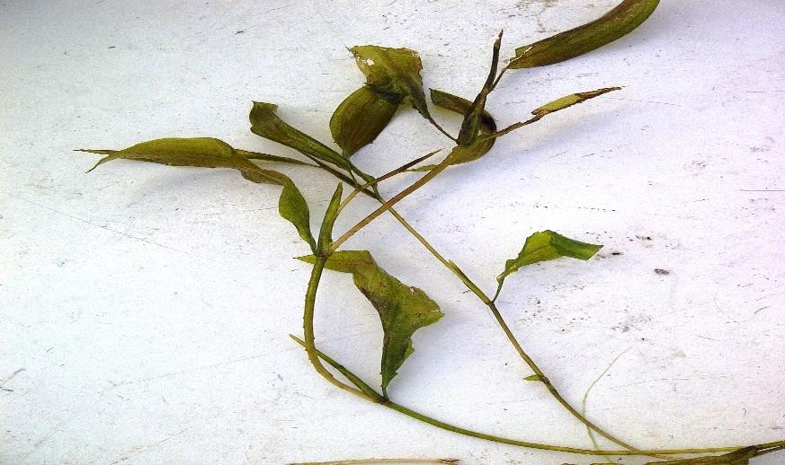

F
igure 1.
L
a
rge
-
leaf Pondwe
ed

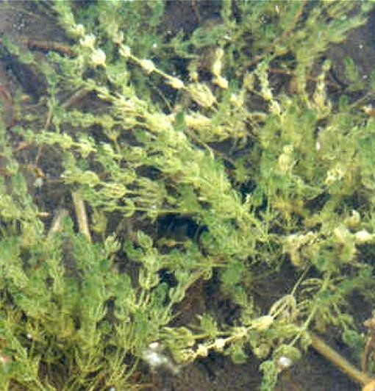

F
igure 2
.
Chara

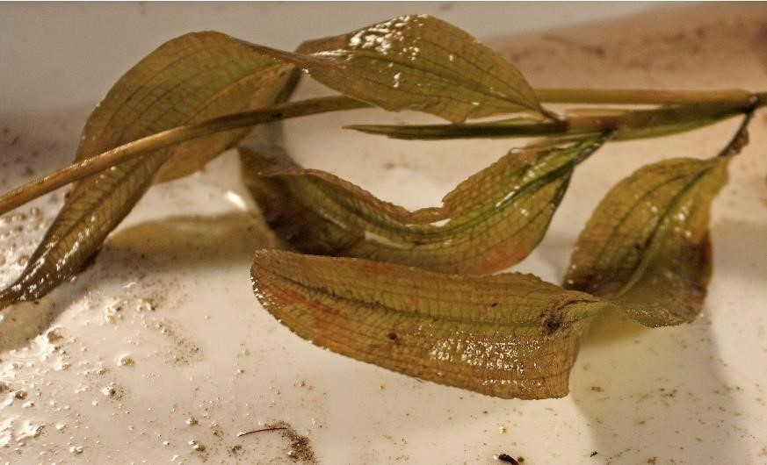

Figure 3. Illinois Pondweed

Table 4. Barron Lake Native Aquatic Plant Species (June 10, 2022).
Native Aquatic Plant Species Name | Aquatic Plant  Common Name | % Cover | Aquatic Plant Growth Habit
Chara vulgaris | Muskgrass | 15.6 | Submersed, Rooted
Potamogeton pectinatus | Thin-leaf Pondweed | 3.0 | Submersed, Rooted
Potamogeton amplifolius | Large-leaf Pondweed | 16.9 | Submersed, Rooted
Potamogeton zosteriformis | Flat-stem Pondweed | 0.2 | Submersed, Rooted
Potamogeton robbinsii | Fern-leaf Pondweed | 8.0 | Submersed, Rooted
Potamogeton natans | Floating-leaf Pondweed | 0.1 | Submersed, Rooted
Potamogeton praelongus | White-stem Pondweed | 0.1 | Submersed, Rooted
Potamogeton illinoensis | Illinois Pondweed | 11.2 | Submersed, Rooted
Vallisneria americana | Wild Celery | 9.4 | Submersed, Rooted
Elodea canadensis | Common Waterweed | 0.2 | Submersed, Rooted
Najas guadalupensis | Southern Naiad | 0.2 | Submersed, Rooted
Nitella sp. | Macroalga | 0.1 | Submersed, Rooted
Nymphaea odorata | White Waterlily | 0.1 | Floating-Leaved, Rooted
Typha latifolia | Cattails | 0.1 | Emergent
Schoenoplectus acutus | Bulrushes | 0.2 | Emergent

Invasive (Exotic) Aquatic Plant Species
The amount of Eurasian Watermilfoil (EWM; Figure 4) and Curly-leaf Pondweed (CLP; Figure 5) present in Barron Lake varies each year and is dependent upon climatic conditions, especially runoff-associated nutrients. In 2021-2022, water levels were lower than in recent years and thus the runoff nutrients were reduced, and the light was increased. Despite the reduction in nutrients from less rain, there was enough nutrient and light to provoke accelerated aquatic plant growth of native and invasive aquatic plant species.
The June 10, 2022 survey revealed that approximately 8.0 acres of milfoil and approximately 4.6 acres of CLP found growing with the EWM. A treatment on August 23, 2022 followed using diquat a dose of 2 gallons per acre with adjuvant to help the herbicide remain on the plants for optimum uptake. The treatment was conducted well after the original survey due to the timing of treatment (avoiding near the July 4 holiday) and also that the acreage was not a concern given the presence in deeper water. An additional survey in July 2022, determined that only 2.6 acres of milfoil remained and that was treated during the August 23, treatment date. Milfoil acreage can sometimes change naturally without treatment if native species take over and result in death of the milfoil plants. Maps showing the distribution of EWM, and CLP are shown below in Figures 6-8.
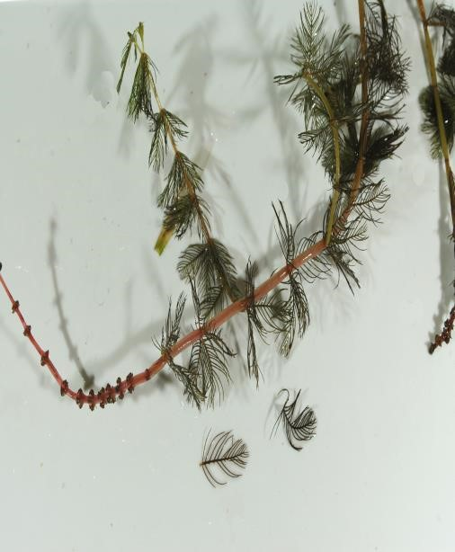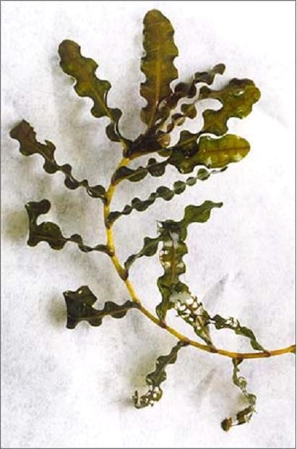

Figure
4
. Eurasian Watermilfoil

Figure
5
.
Curly
-
leaf Pondweed

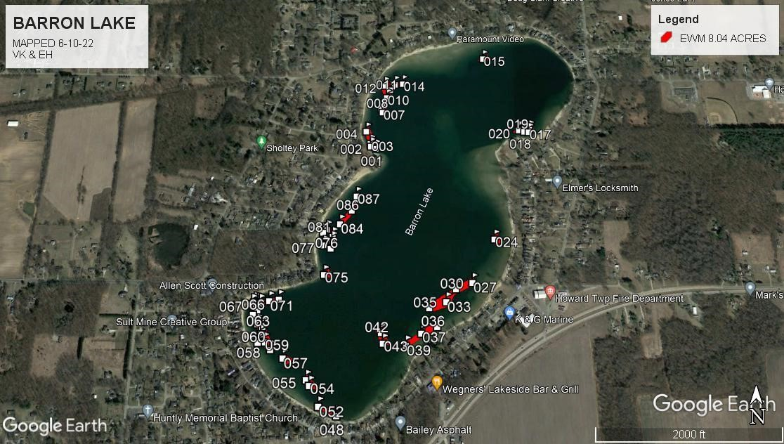

Figure 6. EWM in Barron Lake (June 10, 2022)

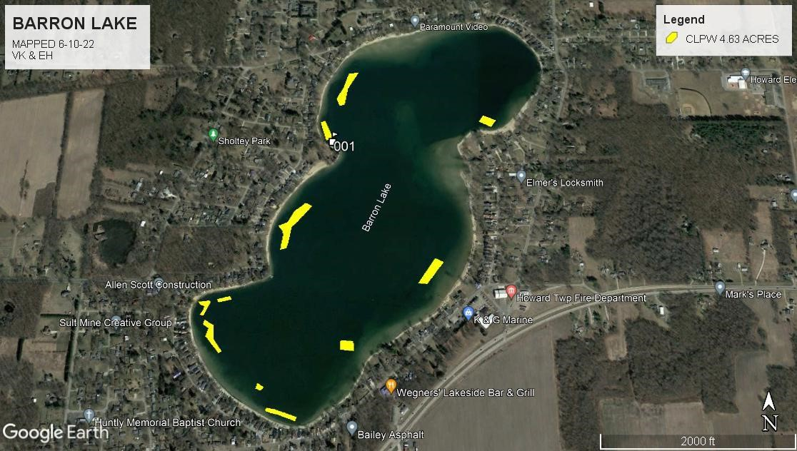

F
igure 7
.
CLP in Barron Lake (
June 10
, 202
2
)

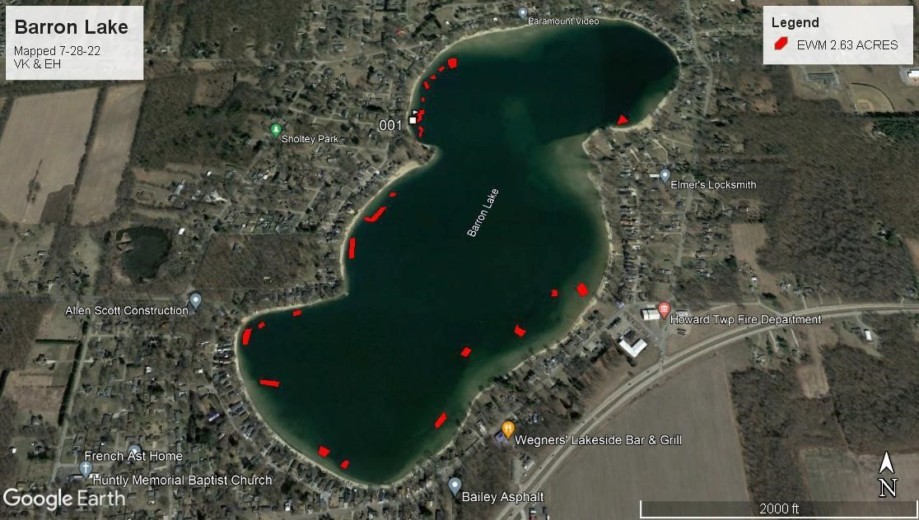

Figure 8. Late Season EWM in Barron Lake (July 28, 2022)

Section 4 Management Recommendations for 2023
Continuous aquatic vegetation surveys are needed to determine the precise locations of EWM, CLP, or other problematic invasives in Barron Lake. These surveys should occur in early-May to early-June and again posttreatment in 2023. A complete native aquatic plant inventory is not recommended until at least mid-summer as many native aquatic plant species do not germinate until after spring. This is especially the case for late-season Wild Celery that has been increasing in the lake. Treatment of Wild Celery is not recommended as herbicides do not result in death of the standing biomass. Mechanical methods are recommended instead for better results.

In 2023, the use of ProcellaCOR® along with diquat may be used to keep the EWM under control and allow for sustained results. ProcellaCOR® treatments conducted in early to mid-summer have reduced the need for additional treatments later in the season in the same areas. RLS will also evaluate all treatments in 2023 and will make regular visits to Barron Lake.

Water quality will be monitored in 2023 in the main lake to determine the health of the lake relative to water quality parameters. RLS has begun tracking trends in numerous water quality parameters to view the changes over time as a tool for future management recommendations.

In conclusion, Barron Lake is a productive lake with good aquatic plant diversity, fairly good water clarity, elevated nutrient loads, and a healthy fishery. It continues to have significant growths of EWM, and CLP. Management of EWM, CLP, and algae will be focal points for 2023.

